Central Texas Section
An IEEE Workshop:

“Successful Consulting in 2017: an IEEE Workshop”

Saturday, September 23, 2017

Hosted by IEEE Central Texas Consultants Network

Successful consultants share their experiences starting and growing successful technical consulting businesses. Learn what you need to know about the latest accounting and legal developments. Listen to an expert describe a structured method for predicting future business trends.

The Agenda:
12:20 – 12:50 Registration and Networking
12:50 – 1:00 Welcome and Opening Remarks
1:00 – 1:40 “The Road to Consulting,” Joe Redfield of Redfield Consulting Services
1:45 – 2:25 “Consulting on Purpose,” Joel Sandahl of ZX Technologies, Inc.
2:30 – 3:00 “Accounting and Tax Issues Related to Starting Your Own Consulting Firm,” Harold Ingersoll of Atchley & Associates, LLP
3:00 – 3:20 Break
3:20 – 4:00 “Looking at Your Career from a Turkey’s Perspective and What to do
Instead,” Marc Miller of Career Pivot
4:05 – 4:45 “A Structured Approach for Looking at the Future,”
David Smith of Strategic Pathways
4:45 – 5:00 Networking

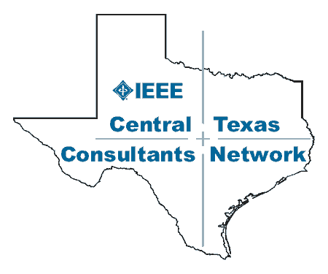

1. The Road to Consulting
By Joe Redfield, Redfield Consulting Services, j.redfield@ieee.org

The story of one man's journey from a happy employee to cheerful independent consultant: Joe will share about his experiences entering the world of consulting and the techniques and methods he used to setup a successful consulting business including how he identified and maintains a client base.
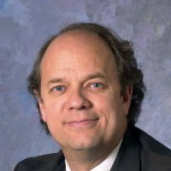Joe is an experienced Energy R&D engineer, and owner of Redfield Consulting Services. Joe is enjoying his role as a consultant following a 30-year career at Southwest Research Institute. He provides his clients with technical and strategic consulting, technical leadership, and project management in the areas of electrified transportation, facility energy management, energy efficiency, smart grid, and alternative fuels. At Southwest Research Institute Joe led teams of scientists and engineers in many successful projects and developed expertise in vehicle-to-grid charge control technologies and systems for plugin electric vehicles, energy storage technologies including Li-ion batteries and fuel cells, advanced transportation drivetrains for plugin electric, hybrid electric, and hybrid hydraulic systems. He has authored and co-author numerous papers published by the IEEE and SAE International.
Joe has been a long time IEEE member and volunteer. He has held many of the leadership positions in the Central Texas Section and has served on the Region 5 Executive Committee on and off for the past 20 years. He currently serves as the Region 5 Membership Development Chair, as position he also holds for the Central Texas Section.

2. Consulting on Purpose
By Joel Sandahl, ZX Technologies, jsandahl@zxtech.net

Joel has been consulting for more than 35 years. Successful consulting begins with “purpose." Joel will share his approach to consulting, which has produced patented industry-changing technologies and five successful startups for the benefit of his clients and himself.

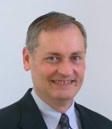Joel is the principal consultant for ZX Technologies, a consulting firm that helps client companies with their business, product, and technology development needs. He has been a consultant for more than 35 years. Joel brings a long and successful track record of diverse business and technology leadership experience to his global clients, which includes:
- VP for Rolled-Ribbon Battery Company LLC
- VP of Worldwide Engineering for Valence Technology, Inc.
- Chief System Architect for EF Johnson Company
- President & CEO of Enhanced Messaging Systems, Inc.
- Director of Advanced Systems & Technology for Motorola, Inc.
- President & CEO for Complex Systems, Inc.
- Chief Scientist and Director Advanced Development for Quintron Corporation
- Managing Director for Simulcomm
- VP of Engineering for Jeff-Comm Corporation
- President & CEO for Cellular Technology, Inc.
- Director of Cellular Engineering for Harris Corporation
Joel is very active in IEEE. He is currently the Central Texas Section PAPR Committee Chair and the Student Branch Liaison for University of Texas at Austin. He is the recent Past-Chair for the Austin Joint Chapter of the Power & Energy, Power Electronics, Industrial Applications and Industrial Electronics Societies.

3. Accounting and Tax Issues Related to Starting Your Own Consulting Firm
By Harold Ingersoll, Atchley & Associates, HINGERSOLL@atchleycpas.com

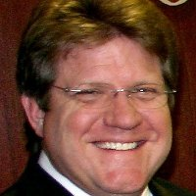Harold has a B.B.A. in Accounting from Texas State University (formerly Southwest Texas State University). Over the last 39+ years in his public accounting career, Harold has served many individuals and organizations in the Central Texas area as President of Ingersoll & Ingersoll, P.C., as a Partner with Faske Lay & Co., L.L.P and currently as a Partner of Atchley & Associates, LLP. Harold is a Certified Public Accountant (CPA), a Certified Valuation Analyst (CVA) and a Certified Merger and Acquisition Advisor (CM&AA). Harold has also obtained his Accredited in Business Valuation (ABV) credential and Certified in Financial Forensics (CFF).
His professional and civic memberships include: American Institute of Certified Public Accountants (AICPA-Member); Business Valuation, Forensic & Litigation Services Section (BV/FLS-Member); Texas Society of Certified Public Accountants (TSCPA-Member); Austin Chapter of the TSCPA (Member); National Society of Accountants (Member); National Association of Certified Valuators and Analysts (Member); Association of Merger and Acquisition Advisors (Member); National Association of Corporate Directors (Member); Rotary Club of Austin (Past President and Director); The Austin Rotary Club Foundation (Director); Austin Asset Management Company (Advisory Board Member); Mission Capital (Board Member & Partner); Easter Seals of Central Texas (Board Member); Recognize Good (Ethics in Business & Community Award Champion Circle Member), Retired United States Air Force
Harold’s practice concentration includes merger and acquisition consulting services, fraud examinations, succession planning, valuation of businesses, business interests, and personal property, management and financial consulting, litigation support (expert witness) services, and income, estate and gift tax preparation and transaction planning.

4. Looking at Your Career from a Turkey’s Perspective and What to do Instead
By Marc Miller, Career Pivot, marc@careerpivot.com
Most turkeys are hatched into a safe environment. They are then fed every day. Every day is very predictable and safe. Life is really good until… the fourth Thursday of November when suddenly life as a Turkey does not look so good. Does this sound like your career? Are you prepared when your current project ends? “Targeted Job Search” is a system which will give you a step by step process to avoid looking like a turkey when your project comes to an end.
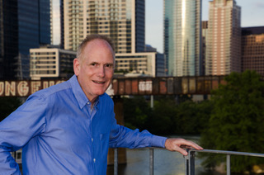Marc Miller’s career journey includes 22 years at IBM, several thriving tech startups, a painful stint as a high school teacher, a gig raising funds for the Jewish Community Association of Austin and a near fatal bicycle accident that changed his perspective forever. The most crucial lesson learned while wandering the career desert: Most people don’t really know what makes them happy at their core. Pursuing money, status, and skills provides some level of satisfaction, but not contentment. Others have figured out what they need, but don’t know how to chart a course to get there. As an active member of the Launch Pad Job Club, Marc found himself counseling friends and associates on their career journeys and realized he’d found his vocation. He now uses his extensive training experience to help others—especially Baby Boomers—find careers that they can grow into for the decades that lie ahead. Marc is passionate about his work and the clients he serves. He’s taught in more than 35 countries and helped clients from many industries.

5. Framework for Looking at the Future
By David Smith, CEO, Strategic Pathways, David_Smith@strategicpathways.com

This talk will present a framework which has been used successfully for predicting the future and as a basis for future strategy. It has been used with many of the Fortune 100, state and federal agencies and small and medium-size business. It is built up on the premise that there are six different views for looking at an understanding the future. That by using the six views your accuracy increases and the insights give you a competitive advantage. This presentation will give you many new tools for your consultant’s toolbox.

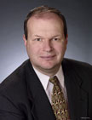David is business leader, futurist, keynote speaker, and wicked problem solver. He has extensive experience making information driven projections to uncover growth opportunities arising from global R&D breakthroughs, new processes, and service capabilities. He also has led the development of an Electronic Health Platform with social networking features which connect doctors, patients, care teams, pharmas, ancillary healthcare providers, and even extended care teams such as fitness and diet care teams. It also harnesses the power of Data Science, Big Data, and distributed clouds to extract meaningful knowledge and wisdom from the health platforms to allow change, improvements, and transformation to occur at all levels from private practices, large health organizations, insurance, pharma, providers to healthcare and the government. David has been CEO of Strategic Pathways for 24 years, and CEO of Social Care for 4 years.

The IEEE Central Texas Consultants Network promotes the development of members' careers through professional and social networking, including publicizing members' skills, sharing potential professional opportunities, and presentations by experts in technology, marketing, sales, advertising, financial or legal needs of small businesses and special needs of consultants. Website is: http://ewh.ieee.org/r5/central_texas/cn/

